**Vision and Mission**

Samsung Research tries to keep its Vision and Mission simple. Their Vision is a slogan for employees to live by in their work - "Shape the Future with Innovation and Intelligence." This means to try and have a positive impact on the future and create a better future through intelligent innovation.

There are three key values to the Samsung Research mission. The first is "Increase Competitive Edge," which means the company wants employees to make new value for the business. The second is "Secure New Growth Engine". The company wants its departments and employees to identify new possible opportunities and markets for the business. The third value is "Innovate Advanced Core technologies". The company aims to get the best leaders and technical talent in the world into its primary business and research areas.

From our initial meeting and insight, it seems as if the Samsung research center in New York truly believes and tries to live by this Vision. Our advisor showed us a massive banner in the hall that was signed by various Samsung leaders and had their Vision printed on it. They talked about the banner with pride, and its location indicates that it is important to the employees.

**Strategy**

Samsung's primary business strategy has been to provide high-quality products with a broad target audience. It is this core strategy that has enabled the conglomerate to execute its other strategies. Although this has worked historically for Samsung, its electronics affiliate has had recent challenges in executing it. As [Ben Thompson](https://stratechery.com/2014/smartphone-truths-samsungs-inevitable-decline/) noted in 2014, Samsung Consumer Electronics' (SCE's) phone business was falling behind Apple's because their fixation on improving device quality did not match with the circumstances of the time: where hardware quality was becoming commoditized, and software was playing a more significant role in the product's value.

Likely because of this, SCE has recently begun to incorporate software into its business. In a [2019 event](https://news.samsung.com/global/samsung-electronics-declares-age-of-experience-at-ces-2020?utm_source=mainkv&amp;utm_medium=internal), the affiliate announced plans to "seamlessly combine hardware and software." That same event saw SCE introduce a wide range of AI-powered IoT devices, including a smart chef and a mobile personal assistant.

Although Samsung Research (SR) has different goals than other Samsung affiliates,they are still heavily influenced by the parent Samsung group. As our advisor, Anthony, stated, "Samsung, at its roots, is primarily a hardware company." Thus, the main objective of Samsung Research (SR) is to develop new ways of using this hardware in Samsung products. SR is pursuing this objective by focusing its research on subjects relevant to the internet of things (IoT): like robotics, data science, 5G, and AI ([Corporate Site](https://research.samsung.com/)). To defeat competitors (other researchers) in this field, SR pushes its employees to work on projects to get a high throughput of discoveries quickly. This manifests itself in the relatively short life-span of research projects: four months versus a typical one year.

**Organizational Structure and Culture**

Samsung has a unique organizational structure. The AI center in NYC belongs to Samsung Research, which is an advanced research and development (R&D) hub of Samsung Electronics. Since Samsung Research and Samsung Electronics’s headquarters are located in Seoul, South Korea, this AI center in NYC is under the Korean system. However, there exists Samsung Research America, and its headquarter is located in Silicon Valley. This regional-based division but not regional-based collisions is confusing, and the company’s organizational structure results in this situation. Two main characteristics are product-type Divisions and geographical groupings ([LEONARD EVANS](http://panmore.com/samsung-corporate-organizational-structure-characteristics-analysis)). The first characteristic emphasizes innovation for the company. Samsung Electronics launched Samsung Research, and Samsung Research settled the AI center in New York. Samsung Research America is the product of geographical groupings.

Samsung used to be heavily influenced by Confucianism. Although such culture can increase employee loyalty and faster speed of decision making, it limits employees to think creatively, slows down the rate of innovation ([John Dudovskiy](https://research-methodology.net/samsung-organizational-culture-seniority-oriented-culture-needs-change/)), and promotes gender inequality.

This patriarchal culture has weakened in recent years, and the culture of Samsung Research is cooperation and creativity. It supports employees’ innovative ideas. Also, self-startup is a new culture to them, and employees independently manage and develop their ideas with funds and consulting from Samsung. NYC AI center also has this encouragingly innovative culture.

Samsung Group has 85 direct Affiliates companies without counting the subsidiaries of the affiliate companies. Among the 85 affiliate companies, there are at least three companies in the world's TOP 500 companies by 'Fortune.' Some famous industrial affiliates include Samsung Electronics, Samsung Heavy Industries, Samsung Engineering, and Samsung C&T. Samsung Electronics is the world's largest information technology company, chipmaker, and consumer electronics maker. The branch that we're working with, Samsung Research Centre, falls under Samsung Electronics. Following a corruption scandal, Samsung Electronics announced a 3 CEO Management structure for the three divisions: IT & Mobile Communications, Consumer Electronics, and Device Solutions. One for each product type.

In summary the organizational structure looks similar to Microsoft's during the Steve Balmer days. The vertical integration is not the same between different divisions. From our research, the display and mobile divisions are tightly integrated. This ensures early access to all displays for Samsung's mobiles. However, the mobile division has to compete with companies such as Apple to gain access to the production facilities of the chip-making division.

**Navigation**

The goal of Samsung Research is not related to P&L. Instead, it focuses on innovation and research. This ensures that our innovative ideas would be heard by people who are genuinely motivated to improve people's lives. Additionally, the studio program provides us access to our studio advisors, Daniel Lee, and Anthony Bisulco. Daniel is an Executive VP who's reportee manages the Samsung Research America division, and Anthony is an ML Research Engineer at Samsung Research. Having an opportunity to interact with engineers as well as executives would aid our cross-disciplinary team in understanding the culture from different perspectives and, thus, navigating the organizational structure at Samsung effectively.

**Organizational Chart**

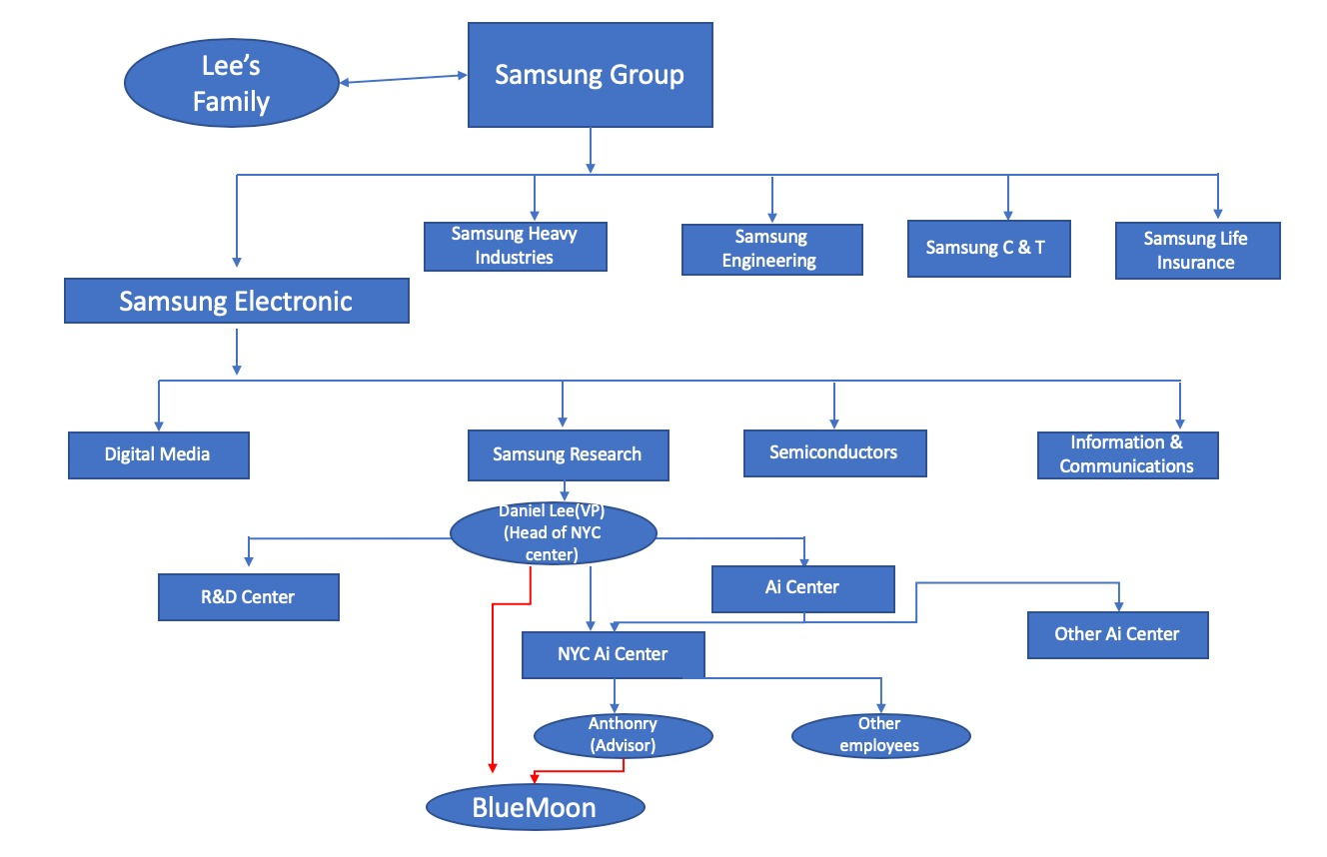

**Reference**

Thompson, Ben. “Smartphone Truths and Samsung's Inevitable Decline.” Stratechery by Ben Thompson, 27 Mar. 2018, [stratechery.com/2014/smartphone-truths-samsungs-inevitable-](http://stratechery.com/2014/smartphone-truths-samsungs-inevitable-) decline/.

Evans, Leonard. “Samsung's Organizational Structure &amp; Its Characteristics (An Analysis).” Panmore Institute, 18 Mar. 2019, [panmore.com/samsung-corporate-organizational-structure-](http://panmore.com/samsung-corporate-organizational-structure-) characteristics-analysis.

Dudovskiy, John. “Samsung Organizational Culture: Seniority-Oriented Culture That Needs to Change - Research-Methodology.” Research, 11 Oct. 2017, [research-methodology.net/](http://research-methodology.net/) samsung-organizational-culture-seniority-oriented-culture-needs-change/.